Exception Handling
Lab Task:
Question#01
Write a program that meets the following requirements:
• Creates an array with 10 randomly chosen integers.
• Prompts the user to enter the index of the array, then displays the corresponding element value. If the specified index is out of bounds, display the message Out of Bounds. (ArrayIndexOutOfBoundsException)
CODE:
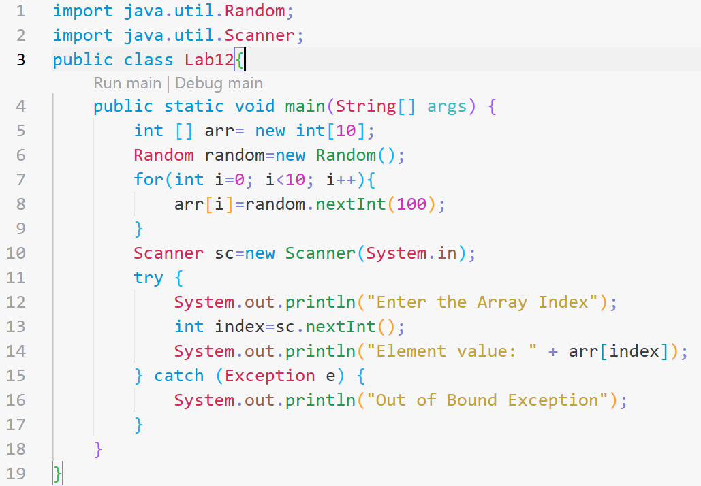
OUTPUT:
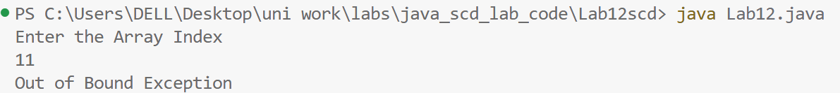

Question#02
Suppose you are developing a game for kids in which they are learning the division operation in math. Your game will take input from kids (2 integers) and then perform the division and displays the answer. Think and apply exception handling in this scenario. For e.g. Arithmetic Exception might occur here. Also suppose, this game has the limitation that it only performs division between integers so if it gets a decimal number as input, it throws an exception stating that the input is invalid, please give integer number etc.
CODE:
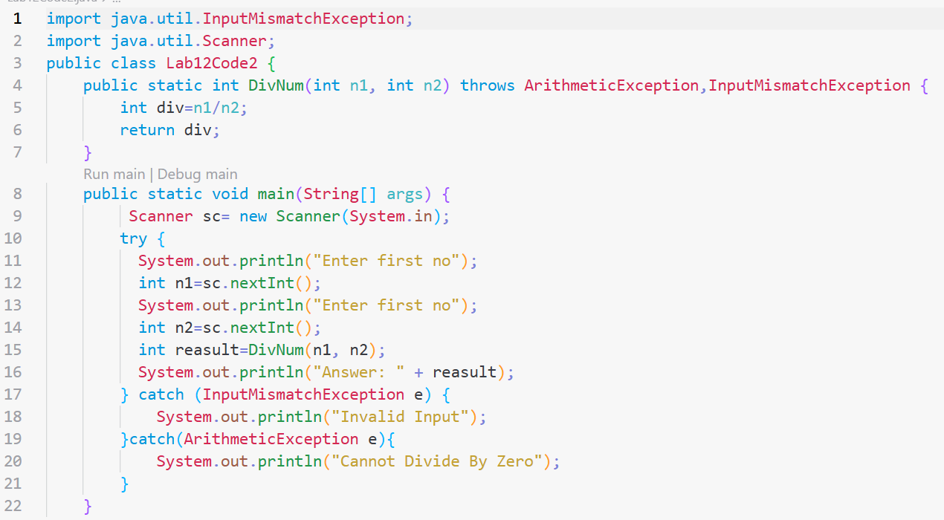
OUTPUT:
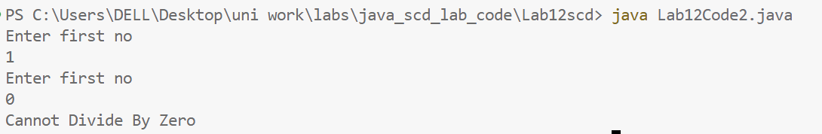
GITHUB SCREEN SHORT
